Hinge packaging line machine operational details: -
Input data:-
1.Product:- Metallic Hinges.
2.Product size: - 180x 140/180x 215
3.Product weight: - Please specify
4.Product line speed: - 23-25 pouches / min
5.Contact parts: - MS powder coated
6.Non-contact parts: - MS powder coated
7.Gear motor: - Bonfiglioli.
8.Servo motor:- Mitsubishi
9.Sensor:- Omron/P&F
10.Foot:- Swift.
11.Belt make:- Chiorino/Forbo/NTB.
12.Chain make:- Dimond.
13.Switch gears:- Schneider
14.HMI:- Mitsubishi
15.PLC:- Mitsubishi
16.Panel:-Local make.
17.Pneumatics:- Festo.

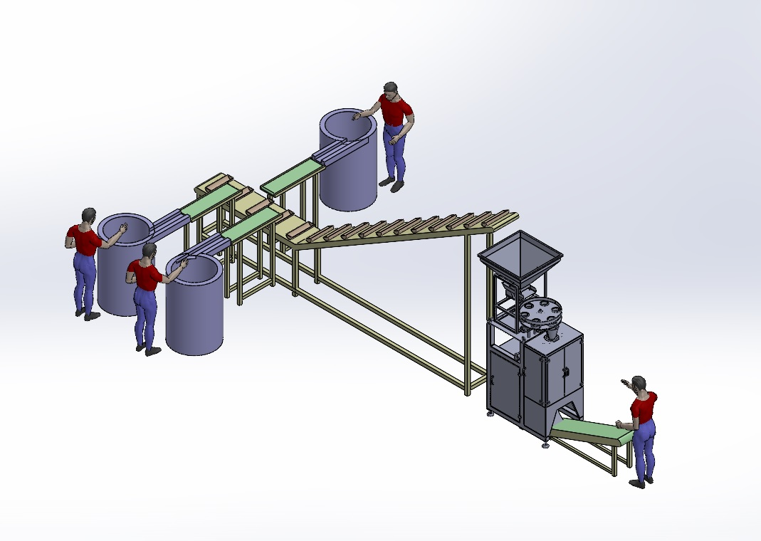

Hinge packaging machine consist of following Items:-
1.Bowl feeder-3 Qty.
2.Belt indexing conveyor-3Qty.
3.Gate assembly-3 Qty.
4.Indexing bucket conveyor -1 qty.
5.VFFS machine-1 qty.
6.Outfeed conveyor-1 qty.

Operational sequence: -
1.Bowl feeder :- Manually we need to feed bulk quantity of hinges into bowl feeder , Bowl feeder will separate out hinges individually .Bowl feeder is PU coated so that noise level is under control and human hearable .This bowl feeder feeds hinges one by one to indexing flat belt conveyor . at the end of bowl feeder there will be a sensor which detect the product presence and once product is passed to indexing belt conveyor , bowl feeder will stop for some time ( time is adjustable)and then starts , this cycle is continuous . There are three bowl feeder each is having different component .
2.Indexig belt conveyor :-This is high friction clitted belt conveyor which work on sensor and indexing type , clits on conveyor helps to create pocket on belt. Hinge came out of bowl feeder will take further to gate assembly.
3.Gate assembly :-Gate assembly is the one who collect the hinges from indexing belt conveyor and drops into the bucket conveyor. Collection of hinges and dropping will be done on sensor basis. Once bucket comes below the gate then gate opens and hinges will fall down. There are 3 gates for each hinge parts.
4.Indexing bucket conveyor: -Indexing bucket conveyor is completely working on sensor and buckets will move indexing fashion. There are 3 sensors below the gates, buckets will stop near to the sensor. Each bucket will get different hinges and then it will move. This filled bucket is then moved to VFFS machine an one by one filled bucket is dumped into VFFS .
5.VFFS machine:- Indexing filled bucket conveyor dumped into VFFS machine then VFFS machine will make pouches and then fill the hinges and then seal the pouches .
6.Outfeed conveyor:-Once VFFS machine creates pouches then these pouches are dropped on to Outfeed conveyor and then it moves to desired height.

